COVID-19: Development of a mathematical model and simulation with consideration of the effect of measures taken to reduce infection rates and time delays

I preferred the REIS model for the base structure of this study as it is simpler to simulate incubation period and related time delays. The aim of this study is to develop a flexible and robust mathematical model to be used in simulations of a pandemia with consideration of measures taken by the society to reduce infection rates based on characteristic parameters of the society and re-susceptibility of the recovered, in order to make more precise predictions.

Assumptions

In this study some assumptions have been made for the sake of simplicity.

Every one exposed to virus will become infected after the t_{incubation} and begins to show symptoms.

During the incubation period, the virus is assumed not to be infectious.

Permanent recovery and re-susceptible recovered people are separated instantly on the recovery time related to re-susceptible ratio.

Base infection rate and time delays are assumed to be determined by field results.

Re-susceptible to recovered ratio is assumed to be determined by the statistics

Methodology

In an SEIR model there are 4 groups of people:

S: number of people who are susceptible to disease
E: number of people who have been exposed to virus and are in the incubation period of the virus
I: number of people who are infected and shows symptoms
R: number of people who have been recovered from the disease

In this model, there is time delays for transitions between these groups:

t_{incubation} : Average incubation time
t_{rec} : Average time spent for the treatment before recovery
t_{hosp} : Average time of infection from the beginning of symptoms to the end of the treatment due to death (period of I )

(note: I have also modeled natural death and birth rates in my model on the application but I set the values to zero. For now I will accept as if natural death and birth rates are excluded)

The transition functions are as blow mentioned:

The daily number of people who are exposed to the virus is Te:

where;
β is the base number for average contact number of the infected and determined by the equation φ/t_{rec} where;

φ is the average number of people who are infected by the same infectious person

σ is the efficiency of the measures and N(t) is the population. S(t)/N(t) represents the possibility of the susceptible contacts per infected person.

The daily number of new infected people is Ti:

The functions of SEIR are as follows:

where;

Rs is the number of re-susceptible people,
Δ is the ratio between death to total recovery.

ξ is the ratio of re-susceptible to total recovery
κ is the survival percentage (for old people over age of 65 year and for young people below age of 65)

N_{old} is the ratio of old people over 65 to total population

By using this model we do not need to assume t_{rec} = t_{hosp.}

(Note: in this model, the R values indicate the permanently immune people. This may need to be changed. Re-susceptible portion of the recovered people are being directly added to susceptible group)

(Note: in the codes of the application, I have used different variable names for some of these. For example i_rec is for the number of recovered people for the time considered)

Behavior of the Society

The symbol of σ represents the efficiency of the measures on reducing the infection rate. In the article of Kok Yew Ng and Meei Mei Gui, this value is modeled as a step function with time delay and constant efficiency. However in real world, there are some motivations that push the society to take further measures related to intensity of the disease.

At the beginning of the disease society tends to be irrelevant to the disease. After a while the society becomes aware of the situation, but after a point society understands the situation wholly and acts swiftly to take measures. And there is an upper limit for the efficiency of the measure due to some limitations like governmental authority, economic factors, social characteristics of the society. So I propose to use a sigmoid function to simulate this characteristic. Also the value of σ should be between 0 and 1, in this respect, sigmoid is a convenient choice.

The daily death rates are preferred as the main factor of the response, because deaths are more striking then infection rates. It is useful to represent severity of the disease. The daily deaths are preferred rather then total death number because the society tends to release the measures as soon as possible. The actual situation is evaluated by the daily cases. When the daily number of cases decreases the society tends to act as if the disease has been transcended. Sometimes this is one of the reasons of prevalence of the disease.

Death numbers are related to population size. So the death numbers should be normalized with population. Here number of daily deaths per 1000000 people is preferred.

Here I formulated this equation as:

x is the daily number of deaths per 1000000 people
a is the parameter for the responsiveness of the society to disease
c is the parameter for the lack of awareness
b is the top limit of the efficiency of the measures.

in my application I set the value of b as 1, so the equation becomes as this on time basis:

the values of a and c could be determined by different methods.

Why Standard SIR Equations are not Suitable?

Standart SIR models has some major assumptions that makes them unreliable for real world predictions when the epidemic, that is under consideration, has remarkable symptoms and measures are taken swiftly by the authorities. This real world data approves that this kind of epidemic has a wavy and chaotic spread sheet, while the SIR models predicts a single wave of epidemic and reaches to a saturation.

In may initial examinations I recognised a pattern that exist inside the chaotic spread of the COVİD-19 epidemic. When I applied a behavioral control function of a kind of sigmoid, there was a relatively rational picture of the spread. Still this kind of approach has some serious assumptions, however, this presents a more resilient way of prediciton for epidemic analysis, and also promotes making comparisons between political systems.

This graph has been produced by the Behavioral Controlled SEIR model
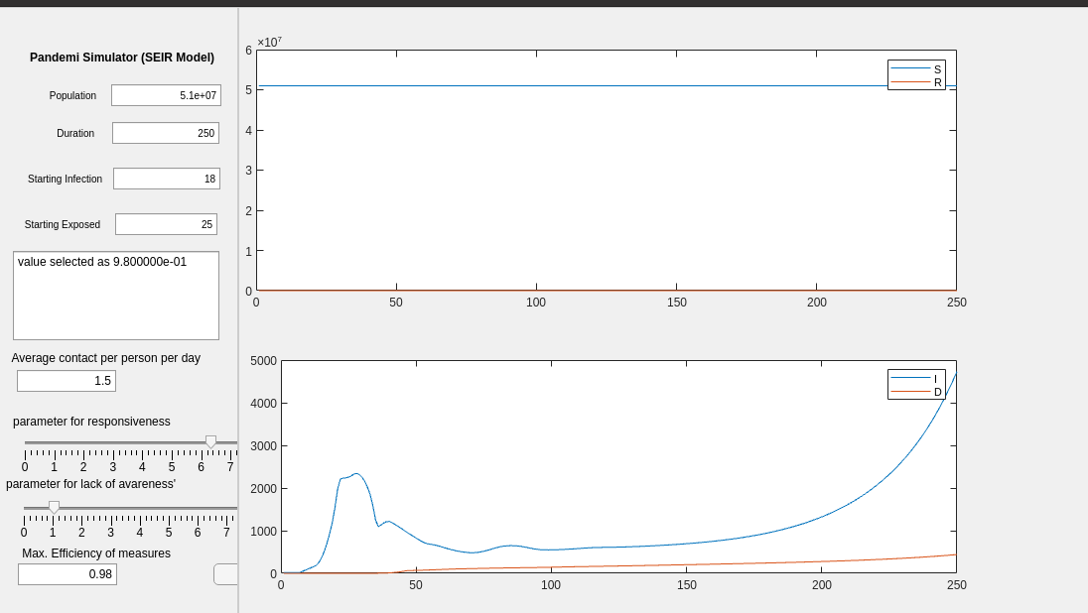

The graph of real data of S.Korea
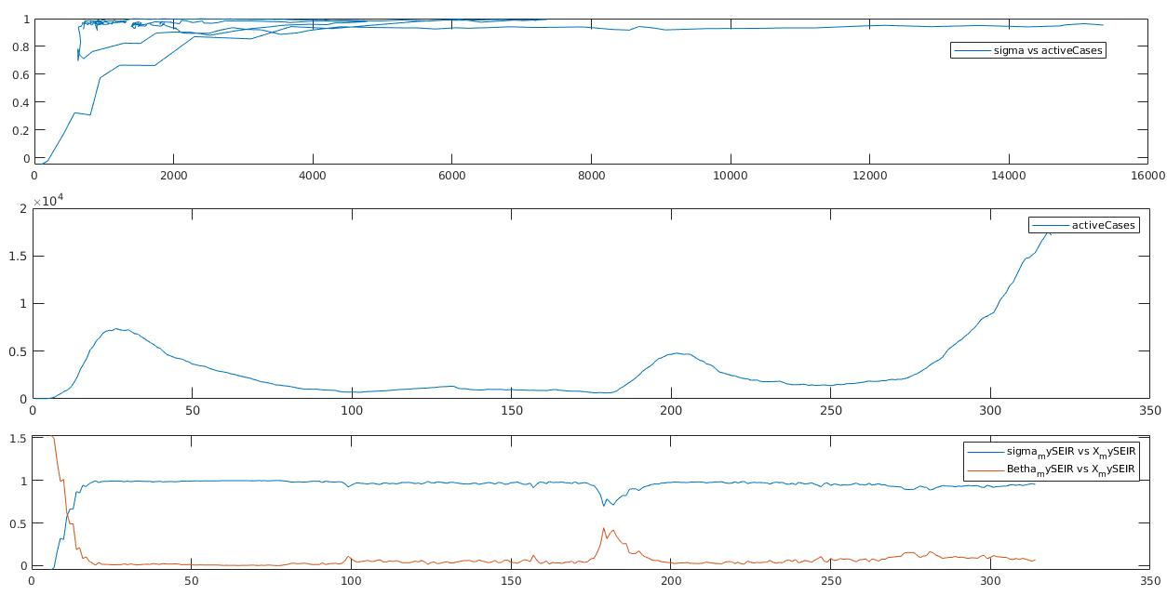
Functions for bifurcation Analysis

if β is the base number for average contact number of the infected and determined by the equation (φ/t_{rec} ) / N_{initial} where;

φ is the average number of people who are infected by the same infectious person

